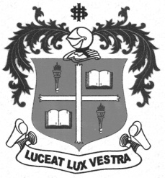
LOYOLA COLLEGE (AUTONOMOUS), CHENNAI – 600 034
B.B.A. DEGREE EXAMINATION – BUSINESS ADMINISTRATION
THIRD SEMESTER – APRIL 2012

BU 3202 - INDUSTRIAL RELATIONS

Date : 02-05-2012 Dept. No. Max. : 100 Marks
Time : 9:00 - 12:00

SECTION A

Answer the following in five lines each: 10 x 2 = 20

- What is Industrial Relation?
- Define Industrial Disputes.
- Define Trade Union.
- Distinguish between Voluntary and Compulsory Arbitration.
- What is known as Hot Stove Rule in Discipline?
- What are Grievances?
- Define a Strike.
- What is Picketing?
- What is known as Code of conduct?
- What is Conciliation?
SECTION B
Answer any five questions in two pages each: 5 x 8 = 40

- What are the causes for Industrial Disputes?
- Explain the characteristics of Industrial Relations.
- What disputes can be referred to the Labour Court, Industrial Tribunal and a National
Tribunal?
- State the objectives of a Trade Union.
- What are the characteristics of Collective Bargaining?
- Explain the V.V.Giri approach to Industrial Relations.
- What are the advantages of Compulsory Arbitration?
- What does a Welfare Labour Officer do in a factory?

SECTION C
Answer any two questions in six pages each: 2 x 20 = 40

- What are the difficulties faced by Indian Trade Unions? Suggest measures to overcome such difficulties.
- Explain the Steps involved in Collective Bargaining.
- What can be done to prevent Industrial Disputes in the factories?
******************

